**B_18_DAYAL ADITYA KISHOR**

**Assignment No. 3**

**Title:**

Implementation of different types of function with suitable examples

* Number function
* Aggregate Function
* Character Function
* Conversion Function
* Date Function

**Problem Statement:**

Create tables in ORACLE using SQL DDL statements  
Sailor(sid:integer, sname:string, rating:integer, age:real)  
Boat(bid:integer, bname:string, color:integer)  
Reserves(sid:integer, bid:integer, day:date)

1. Insert following records in the above tables  
   Sailors

|  |  |  |  |
| --- | --- | --- | --- |
| sid | sname | rating | age |
| 22 | Dustin | 7 | 45.0 |
| 29 | Brutus | 1 | 33.0 |
| 31 | Lubber | 8 | 55.5 |
| 32 | Andy | 8 | 25.5 |
| 58 | Rusty | 10 | 35.0 |
| 64 | Horatio | 7 | 35.0 |
| 71 | Zorba | 10 | 16.0 |
| 74 | Horatio | 9 | 35.0 |
| 85 | Art | 3 | 25.5 |
| 95 | Bob | 3 | 63.5 |

Boat

|  |  |  |
| --- | --- | --- |
| bid | bname | color |
| 101 | Interlake | Blue |
| 102 | Interlake | Red |
| 103 | Clipper | green |
| 104 | Marine | red |

Reserves

|  |  |  |
| --- | --- | --- |
| sid | bid | day |
| 22 | 101 | 10/10/98 |
| 22 | 102 | 10/10/98 |
| 22 | 103 | 10/8/98 |
| 22 | 104 | 10/7/98 |
| 31 | 102 | 11/10/98 |
| 31 | 103 | 11/6/98 |
| 31 | 104 | 12/12/98 |
| 64 | 101 | 9/5/98 |
| 64 | 102 | 9/8/98 |
| 74 | 103 | 9/8/98 |

1. Find name of sailors and display the names in upper case who have reserved boat with name ‘Interlake’
2. Find the rating of sailors whose name contain ‘us’ substring.
3. Find the average age of sailors with a rating of 8.
4. Count the number of sailors with a rating greater than 5.
5. Select date of reservation of boat with bid = 101 reserved by sailor with sid =64 add 2 months in the date and display it.
6. Find the m onths between date 12/02/2021 and system current date.
7. Find name of the boat with month of reservation of boat.
8. Demonstrate use of following numeric functions with suitable examples  
   ABS, SIGN, POWER, ROUND, MOD, FLOOR, CEIL, and TRUNC
9. Find the square root of ages of all sailors
10. Display dates of all boat reservation in the format eg. 19-Jan-2005
11. Find the min and max rating from Sailors

Answers :

1.

create table Sailor(Sid int primary key,Sname varchar(20),rating int,age real);

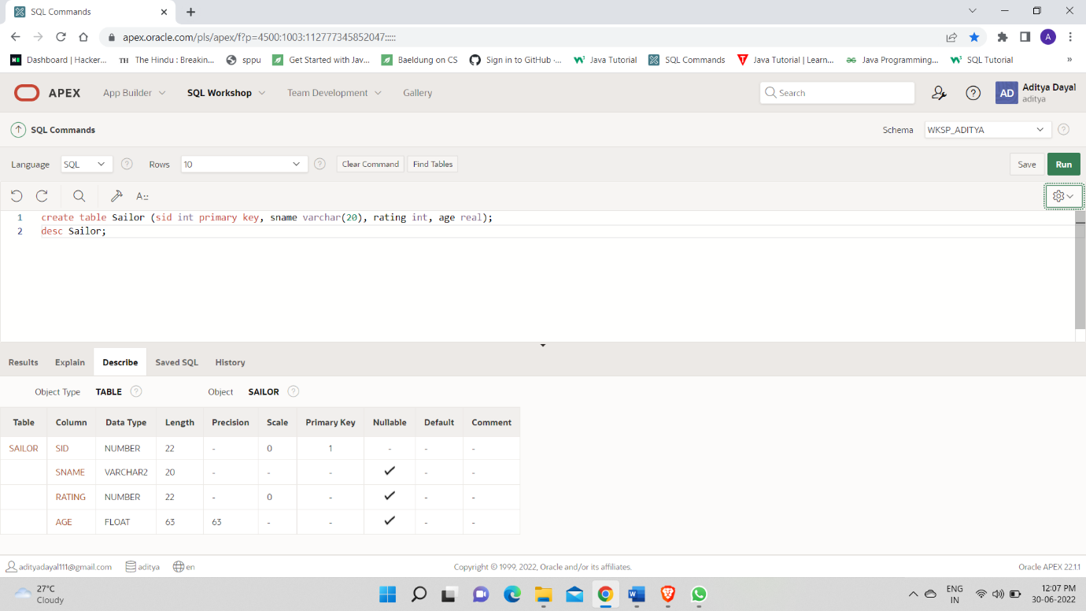

create table Boat ( bid int primary key, bname varchar(20), color varchar(20));

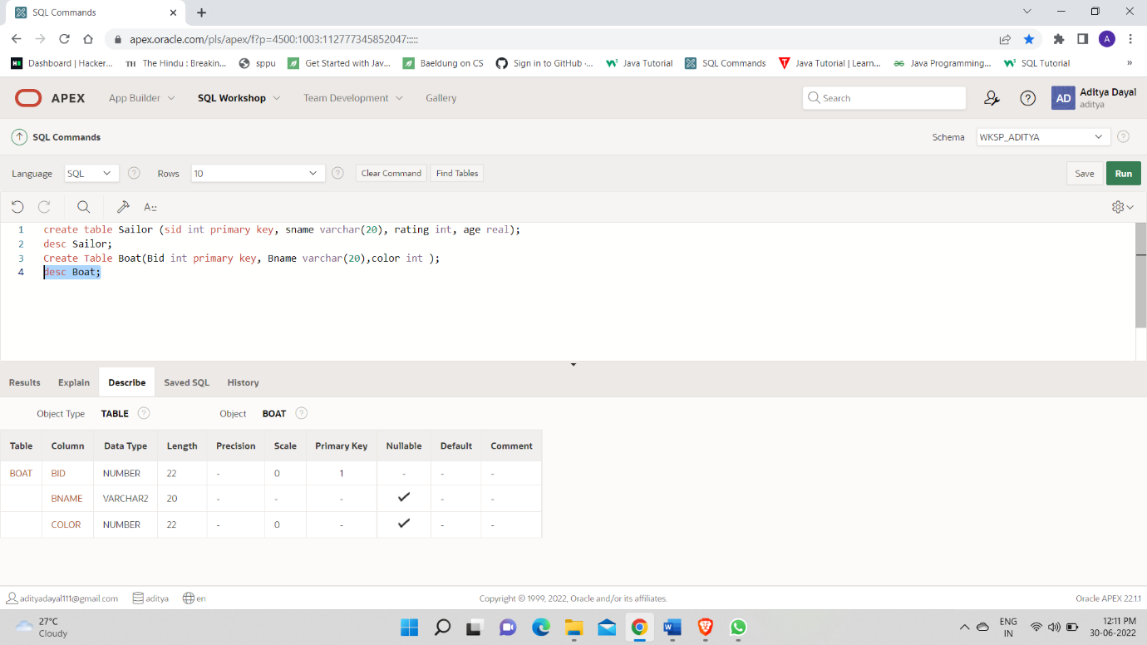

create table Reserves(sid int, bid int, day date, foreign key(sid) references Sailor1(sid) on delete cascade,foreign key(bid) references Boat(bid) on delete cascade);

desc Reserves;

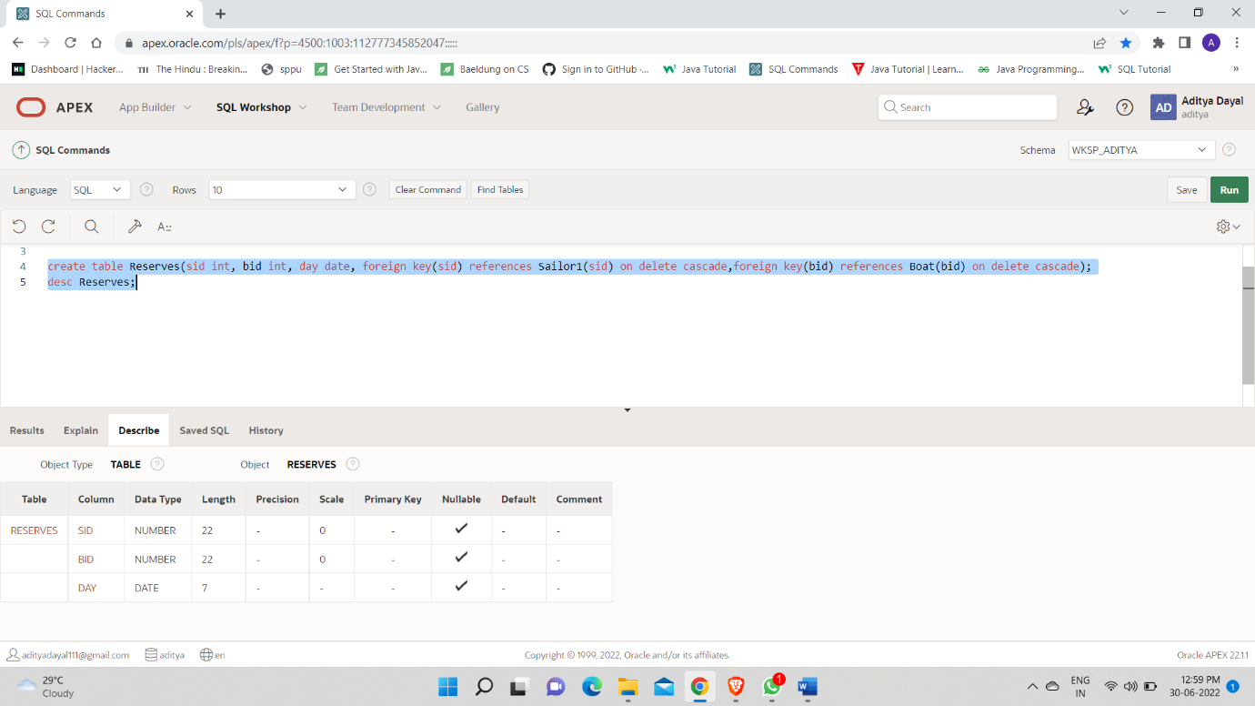

1.

insert into Sailor1 values ( 22, 'Dustin', 7, 45.0 );

insert into Sailor1 values ( 29, 'Brutus', 1, 33.0 );

insert into Sailor1 values ( 31, 'Lubber', 8, 55.5 );

insert into Sailor1 values ( 32, 'Andy', 8,25.5 );

insert into Sailor1 values ( 58, 'Rusty', 10, 35.0 );

insert into Sailor1 values ( 64, 'Horatio', 7, 35.0 );

insert into Sailor1 values ( 71, 'Zorba', 10, 16.0 );

insert into Sailor1 values ( 74, 'Horatio', 9, 35.0 );

insert into Sailor1 values ( 85, 'Art', 3, 25.5 );

insert into Sailor1 values ( 95, 'Bob', 3, 63.5 );

Select * from Sailor1;

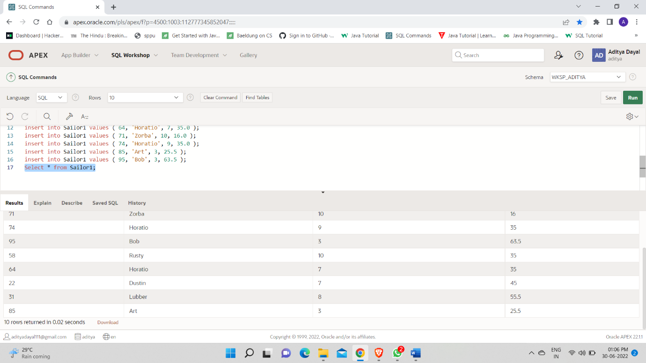

insert into Boat values(101,'Interlake', 'blue');

insert into Boat values(102,'Interlake', 'red');

insert into Boat values(103,'Clipper', 'green');

insert into Boat values(104,'Marine', 'red');

Select *From Boat;

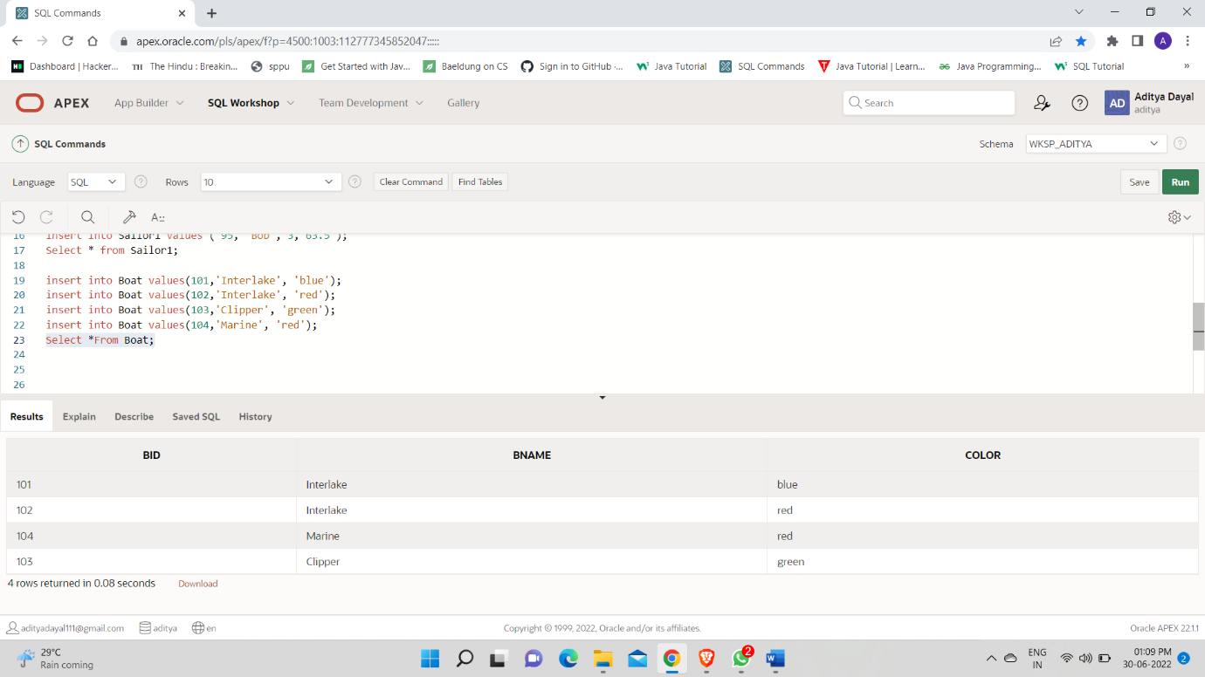

insert into Reserves values(22,101,'10/10/1998');

insert into Reserves values(22,102,'10/10/1998');

insert into Reserves values(22,103,'10/8/1998');

insert into Reserves values(22,104,'10/7/1998');

insert into Reserves values(31,102,'11/10/1998');

insert into Reserves values(31,103,'11/6/1998');

insert into Reserves values(31,104,'12/12/1998');

insert into Reserves values(64,101,'9/5/1998');

insert into Reserves values(64,102,'9/8/1998');

insert into Reserves values(74,103,'9/8/1998');

Select *From Reserves;

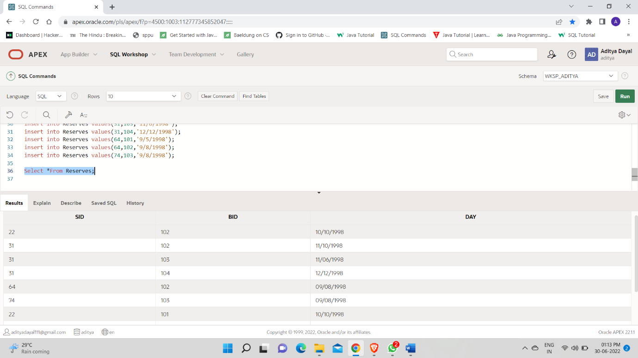

2.

select UPPER(sname) from Sailor where sid in(select sid from Reserves inner join Boat on Reserves.bid = Boat.bid where Boat.bname='Interlake');

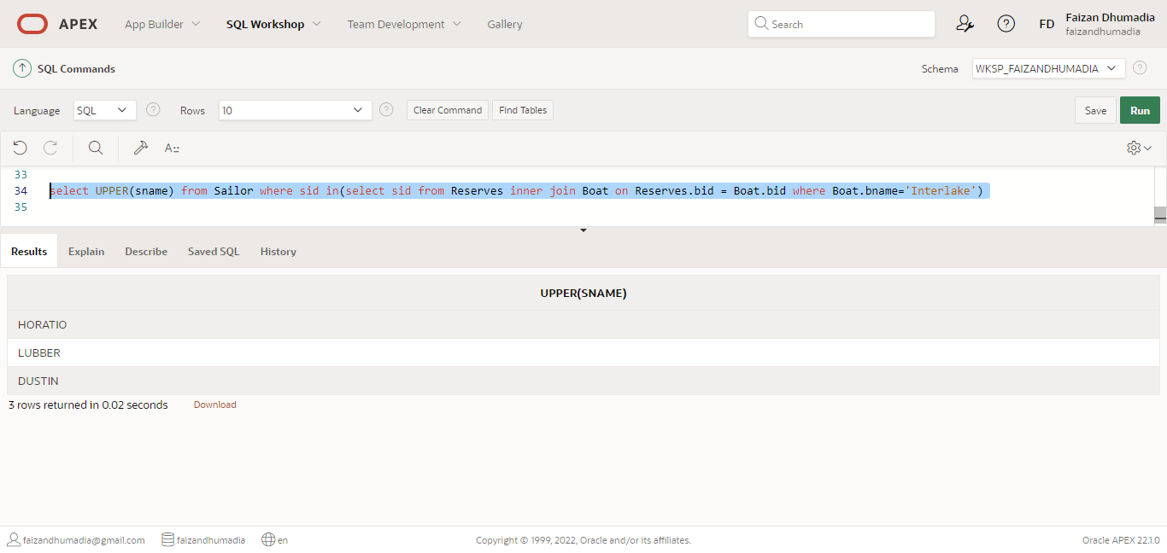

3.

select rating from sailor1 where sname like '%us%';

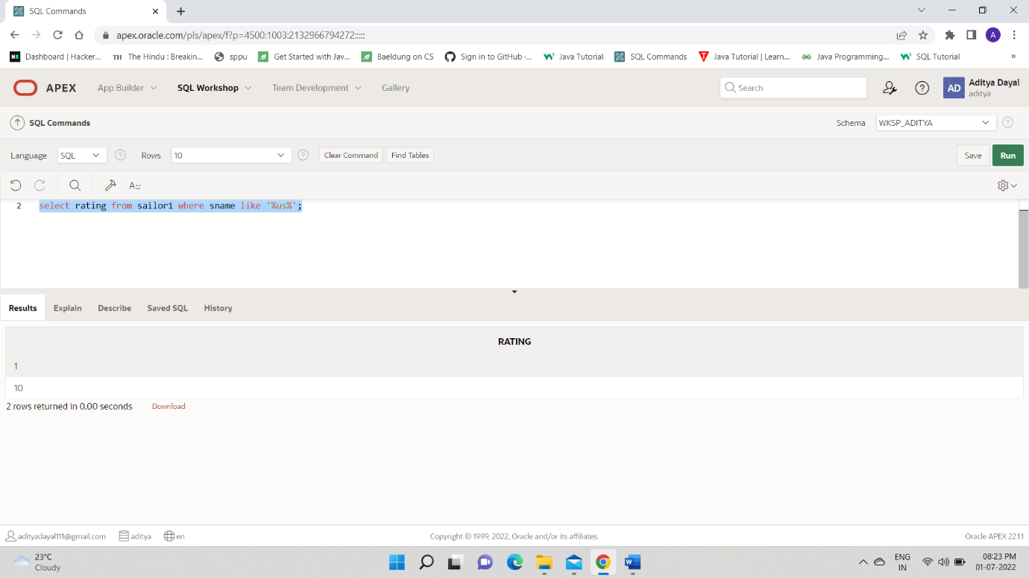

4.

select avg(age) from Sailor1 where rating=8;

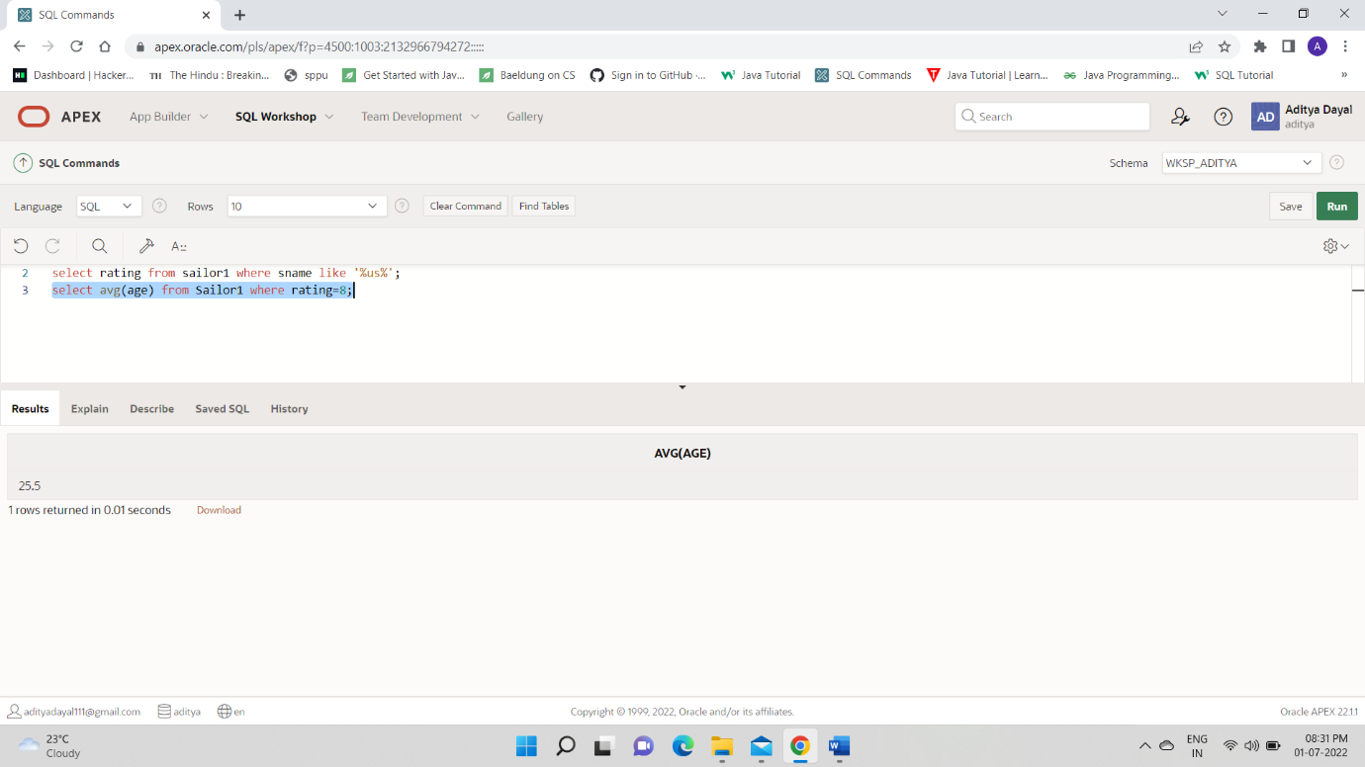

5.

select count(*) "Count" from sailor where rating > 5 ;

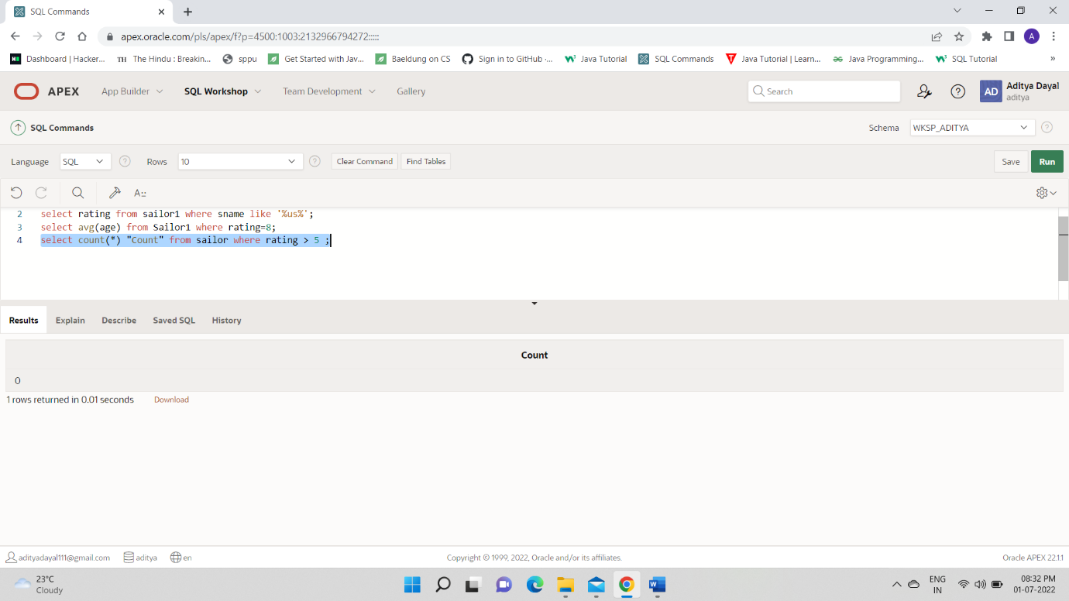

6.

select add_months(day,2) "added 2 months" from reserves where sid=64 and bid=101

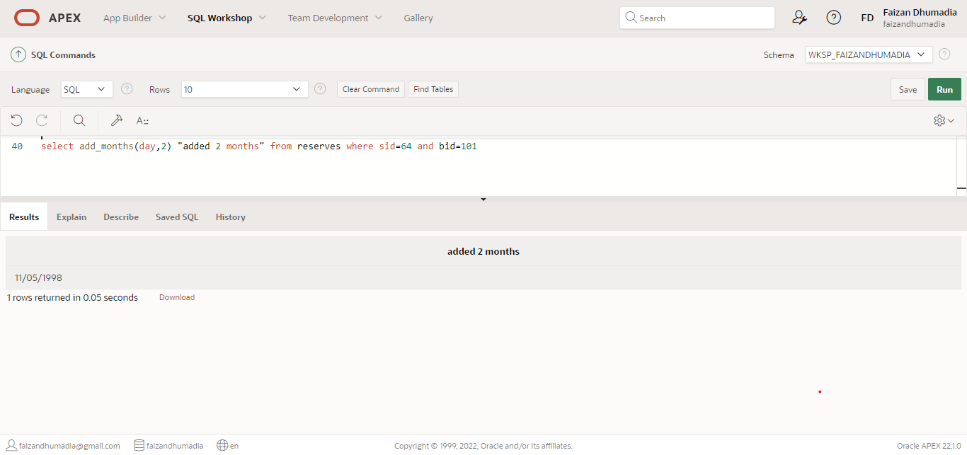

7.

SELECT avg(MONTHS_BETWEEN(SYSDATE,TO_DATE( '02-12-2021','DD-MM-YYYY' ))) FROM Sailor1;

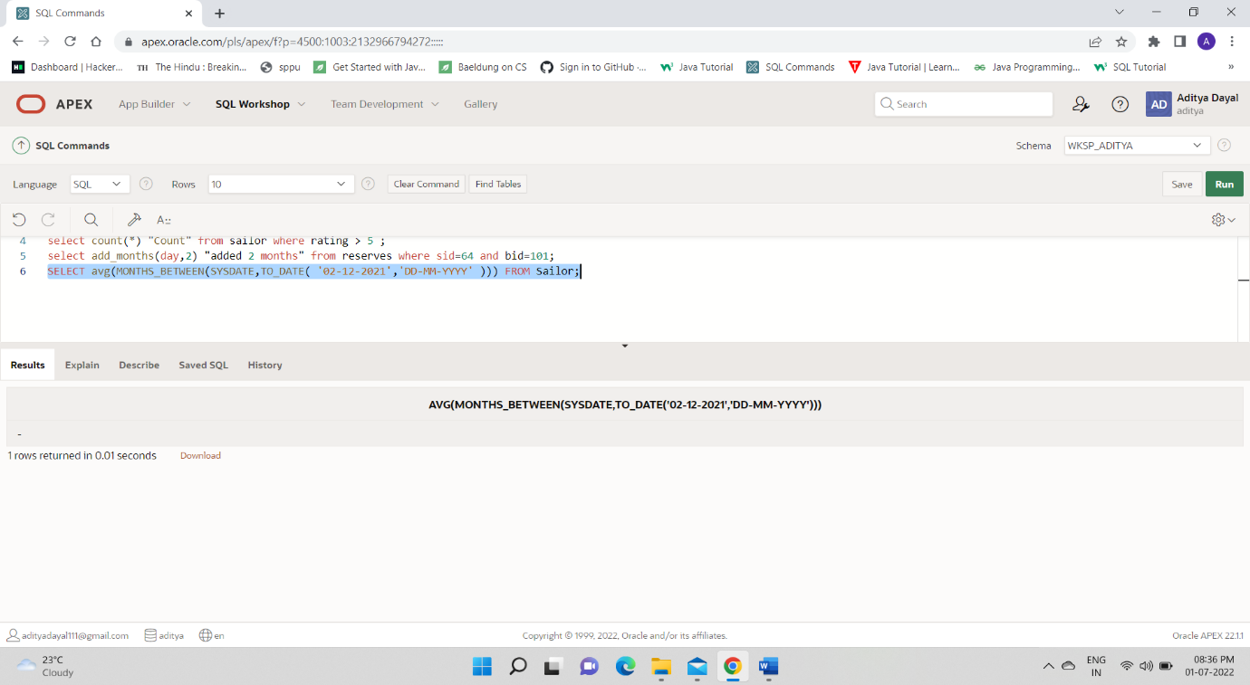8.

SELECT DISTINCT BNAME, EXTRACT(MONTH FROM DAY) "RESERVATION MONTH" FROM BOAT, RESERVES WHERE RESERVES.BID=BOAT.BID;

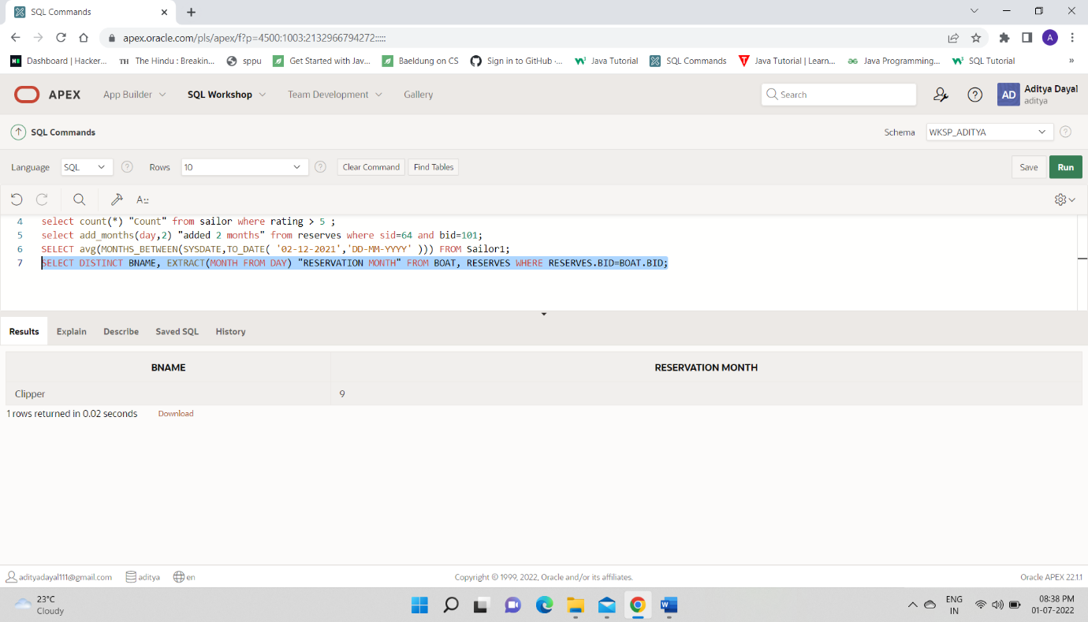

9. Demonstrate use of following numeric functions with suitable examples ABS, SIGN, POWER, ROUND, MOD, FLOOR, CEIL, and TRUNC

SELECT ABS(-22) FROM DUAL;

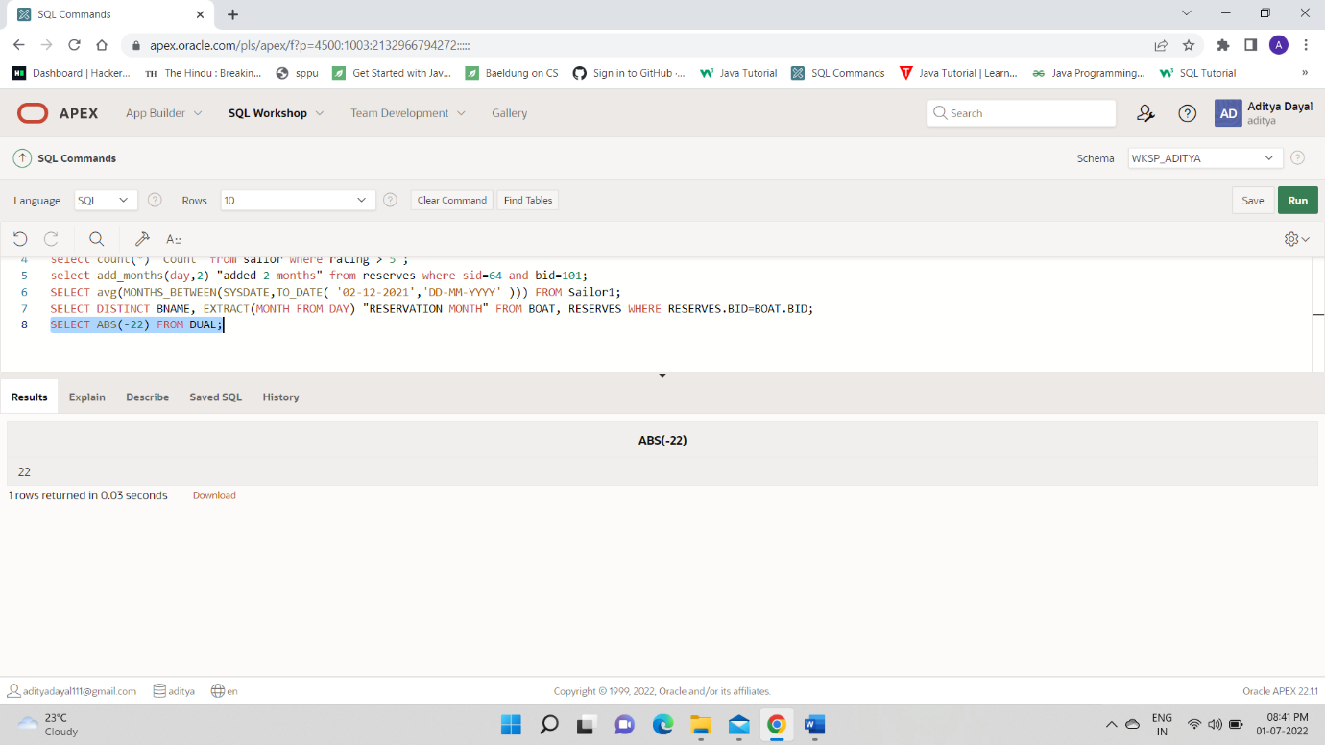

SELECT SIGN(1) AS X, SIGN(0) AS Y, SIGN(-2) AS Z FROM DUAL

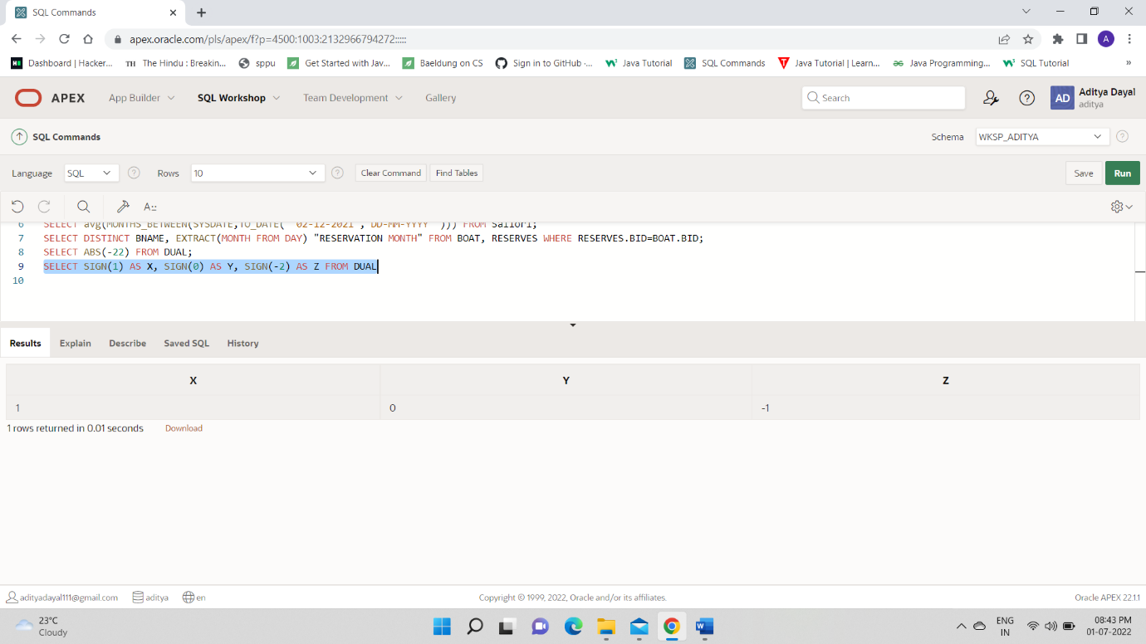

SELECT POWER(3,3) AS CUBE_OF_3 FROM DUAL

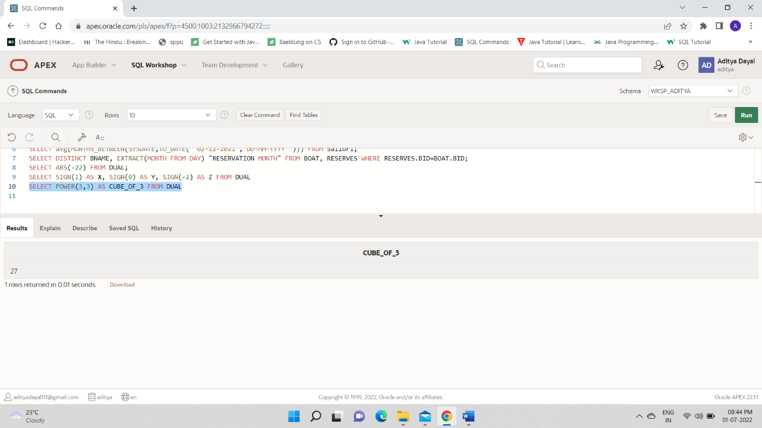  
SELECT ROUND(2.356), ROUND(21.862) FROM DUAL

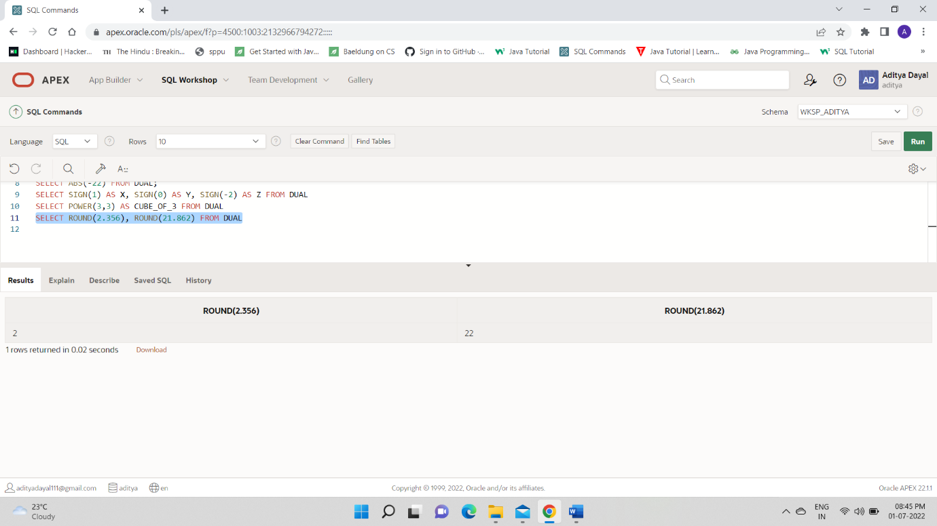

SELECT MOD(10,4) "10_BY_4" FROM DUAL

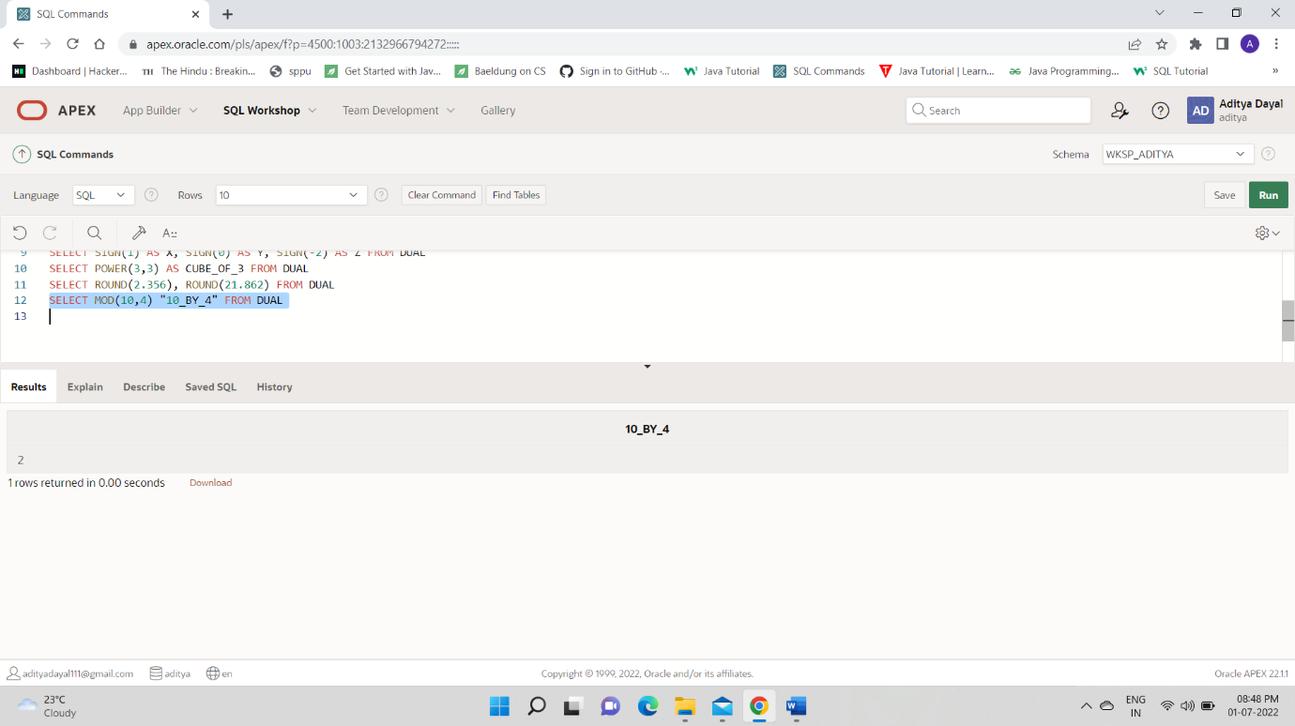  
SELECT FLOOR(12.567), CEIL(12.567) FROM DUAL

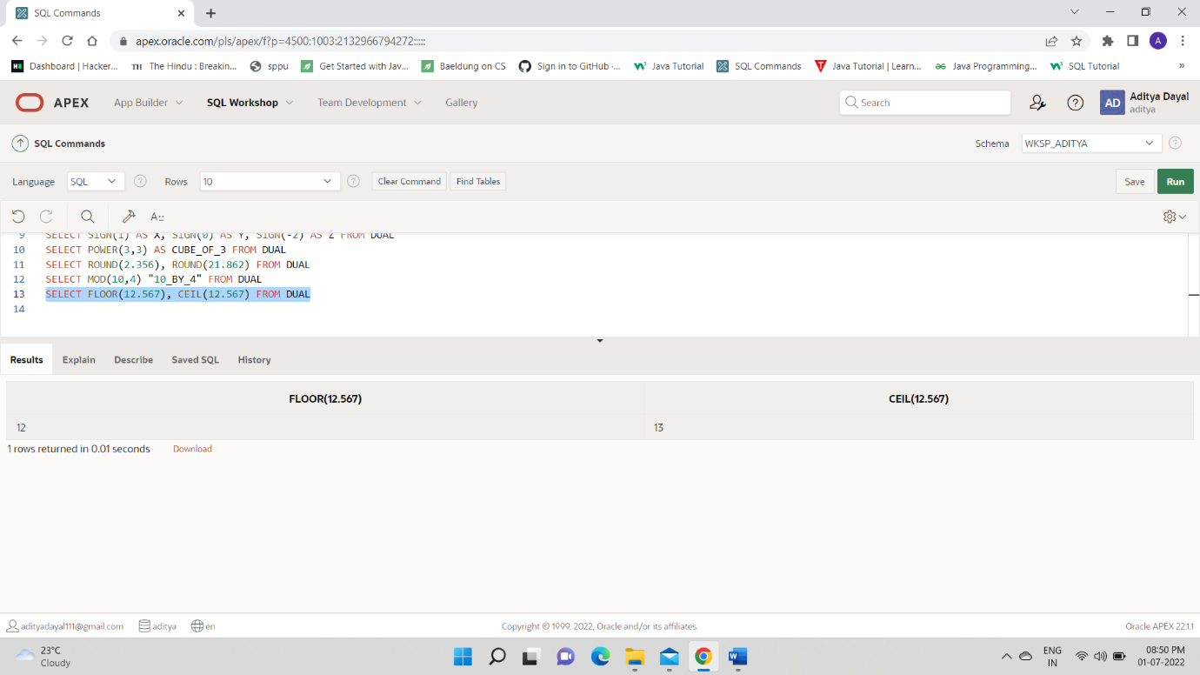

SELECT TRUNC(21.789789789) FROM DUAL

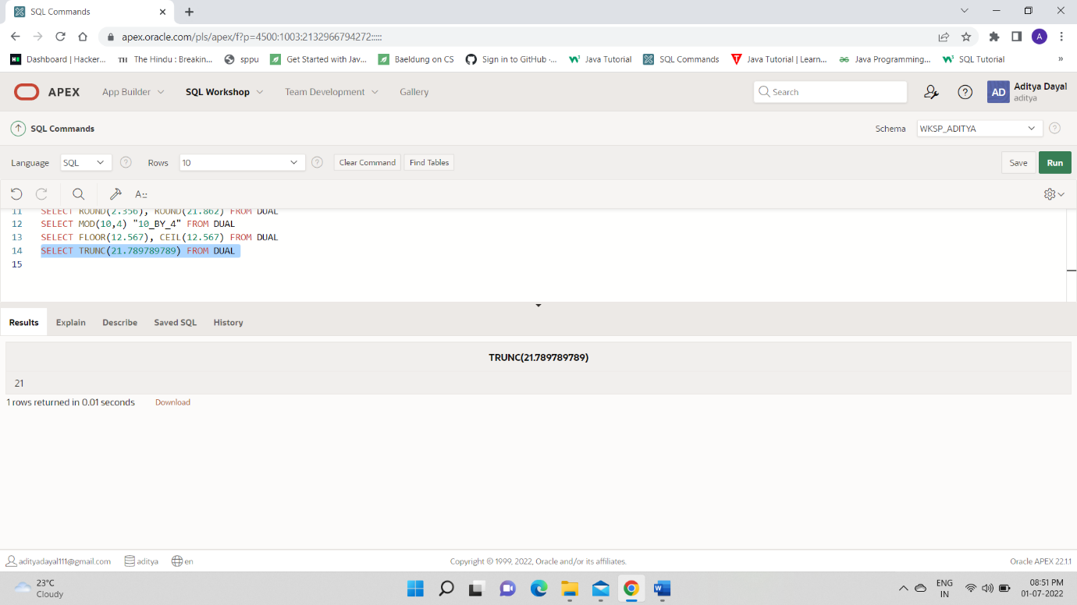

10

select sname,sqrt(age)from sailor1;

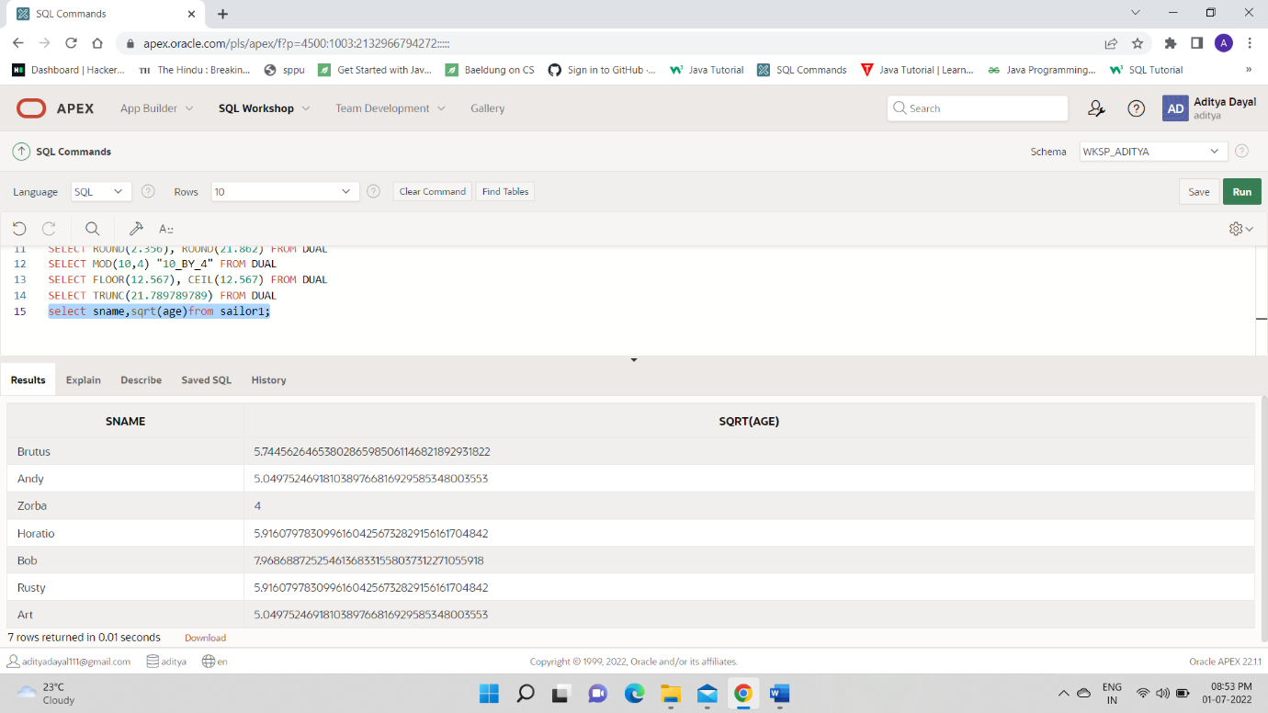

11.

SELECT TO_CHAR(DAY,'DD-MON-YYYY') FROM RESERVES

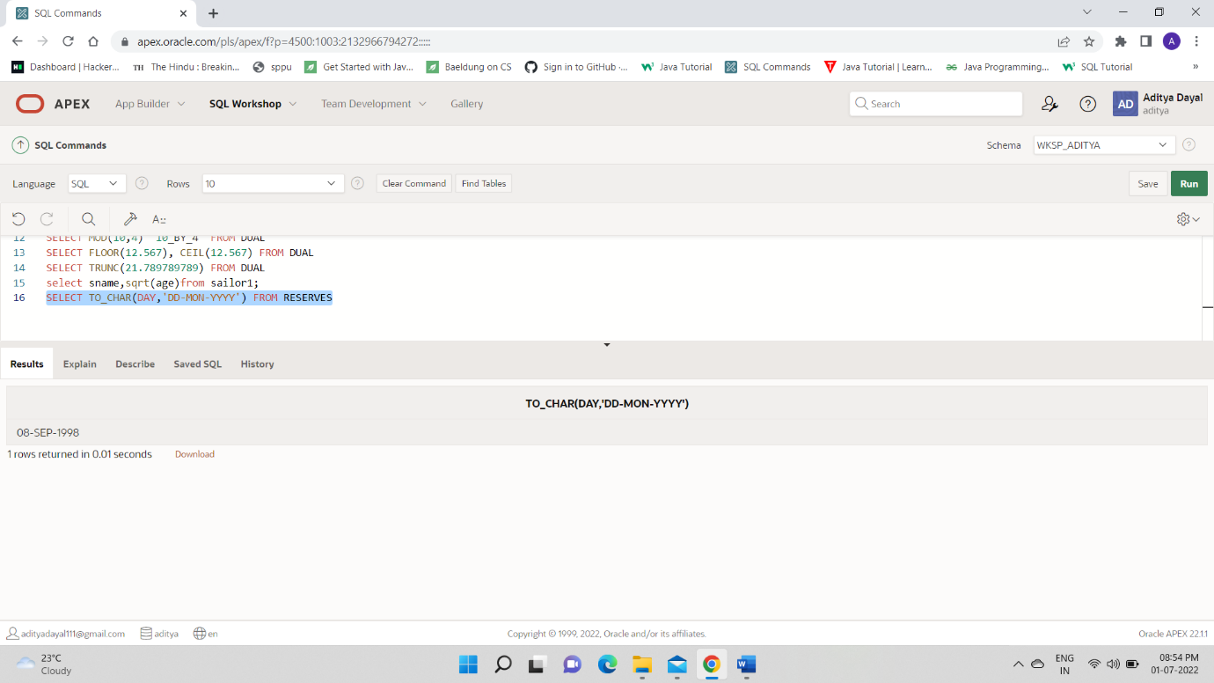

12.

select min(rating),max(rating) from sailor1;

